TASK 12 | Simulate Gaming concepts using Pygame
Problem 1:
Mr.John wants to design a breakout game Game. Help Mr.John to design the Game.
PROGRAM
import pygame
import random

pygame.init() # initializes the Pygame library

white = (255, 255, 255) # sets the colors
black = (0, 0, 0)
blue = (0, 0, 255)
red = (255, 0, 0)
green = (0, 255, 0)

window_width = 600 # defines the window dimensions
window_height = 500
brick_width = 60
brick_height = 20

fps = 60

window = pygame.display.set_mode((window_width, window_height)) # The game window is created
pygame.display.set_caption("Breakout Game") # to set the title to the game window

paddle = pygame.Rect(window_width // 2 - 50, window_height - 30, 100, 10) # paddle is a rectangle positioned near the bottom of the screen (x axis, y axis, width,height)
paddle_speed = 7 # the paddle will move 7 pixels in the respective direction.

ball = pygame.Rect(window_width // 2 - 10, window_height // 2 - 10, 20, 20)
ball_speed_x = 5 * random.choice((1, -1)) # The ball starts moving at a speed of 5 pixels in both the x and y directions.
ball_speed_y = -5

brick_rows = 5 # Grid of Bricks# has 5 rows and 10 columns of bricks.
brick_columns = 10
bricks = []
for row in range(brick_rows):
brick_row = []
for col in range(brick_columns):
brick = pygame.Rect(col * (brick_width + 10) + 35, row * (brick_height + 5) + 35, brick_width, brick_height)
brick_row.append(brick) # Each brick is added to the bricks list.
bricks.append(brick_row)

def draw_bricks(): # Function to Draw Bricks
for row in bricks:
for brick in row:
pygame.draw.rect(window, blue, brick)

def move_ball(): # Ball Movement and Collision Detection
global ball_speed_x, ball_speed_y

ball.x += ball_speed_x
ball.y += ball_speed_y

if ball.left <= 0 or ball.right >= window_width:
ball_speed_x *= -1
if ball.top <= 0:
ball_speed_y *= -1

if ball.colliderect(paddle):
ball_speed_y *= -1

for row in bricks:
for brick in row:
if ball.colliderect(brick):
row.remove(brick)
ball_speed_y *= -1
break

if ball.bottom >= window_height:
return False
return True

def display_text(text, size, color, x, y): #Display Text "Game Over!" on the Screen
font = pygame.font.SysFont("comicsansms", size)
text_surface = font.render(text, True, color)
window.blit(text_surface, (x, y)) #used to draw one surface onto another.

def breakout_game():
running = True
clock = pygame.time.Clock()

while running:
for event in pygame.event.get():
if event.type == pygame.QUIT:
running = False

keys = pygame.key.get_pressed()
if keys[pygame.K_LEFT] and paddle.left > 0:
paddle.x -= paddle_speed
if keys[pygame.K_RIGHT] and paddle.right < window_width:
paddle.x += paddle_speed

if not move_ball():
display_text("Game Over!", 50, red, window_width // 2 - 130, window_height // 2)
pygame.display.flip()
pygame.time.delay(2000)
running = False

if all(len(row) == 0 for row in bricks):
display_text("You Win!", 50, green, window_width // 2 - 130, window_height // 2)
pygame.display.flip()
pygame.time.delay(2000)
running = False

window.fill(black)

pygame.draw.rect(window, white, paddle)

pygame.draw.ellipse(window, red, ball)

draw_bricks()

pygame.display.update()

clock.tick(fps)

pygame.quit()

breakout_game()

OUTPUT
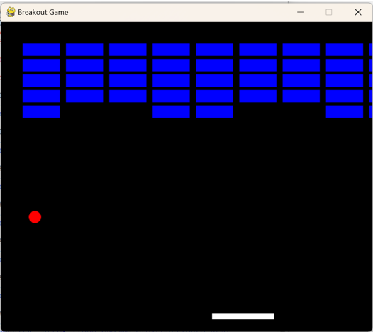

Problem 2:
Mr.Nelson wants to design a Sudoku Game. Help Mr.Nelson to design the Game.
Program:
import pygame
import time
pygame.init()
WIDTH, HEIGHT = 540, 600
win = pygame.display.set_mode((WIDTH, HEIGHT))
pygame.display.set_caption("Sudoku")
WHITE = (255, 255, 255)
BLACK = (0, 0, 0)
GREY = (128, 128, 128)
BLUE = (0, 0, 255)
font = pygame.font.SysFont("comicsans", 40) # font for rendering numbers in the grid is set up
small_font = pygame.font.SysFont("comicsans", 20)
board = [ #Sudoku Board Initialization
[5, 3, 0, 0, 7, 0, 0, 0, 0],
[6, 0, 0, 1, 9, 5, 0, 0, 0],
[0, 9, 8, 0, 0, 0, 0, 6, 0],
[8, 0, 0, 0, 6, 0, 0, 0, 3],
[4, 0, 0, 8, 0, 3, 0, 0, 1],
[7, 0, 0, 0, 2, 0, 0, 0, 6],
[0, 6, 0, 0, 0, 0, 2, 8, 0],
[0, 0, 0, 4, 1, 9, 0, 0, 5],
[0, 0, 0, 0, 8, 0, 0, 7, 9]
]
def draw_grid(): #Drawing the Grid:
gap = WIDTH // 9 # Gap between the lines
for i in range(10):
if i % 3 == 0:
thick = 4
else:
thick = 1
pygame.draw.line(win, BLACK, (0, i * gap), (WIDTH, i * gap), thick)
pygame.draw.line(win, BLACK, (i * gap, 0), (i * gap, WIDTH), thick)
def draw_numbers(board): # Drawing Numbers:
gap = WIDTH // 9
for i in range(9):
for j in range(9):
if board[i][j] != 0:
text = font.render(str(board[i][j]), True, BLACK)
win.blit(text, (j * gap + 15, i * gap + 15))
def draw_selected(row, col): #Highlighting Selected Cell:
gap = WIDTH // 9
pygame.draw.rect(win, BLUE, (col * gap, row * gap, gap, gap), 4)
def main(): # The game loop is started, and once exited, Pygame cleans up and exits properly.
key = None
row = -1
col = -1
run = True
while run:
for event in pygame.event.get():
if event.type == pygame.QUIT:
run = False
if event.type == pygame.KEYDOWN:
if event.key == pygame.K_1:
key = 1
if event.key == pygame.K_2:
key = 2
if event.key == pygame.K_3:
key = 3
if event.key == pygame.K_4:
key = 4
if event.key == pygame.K_5:
key = 5
if event.key == pygame.K_6:
key = 6
if event.key == pygame.K_7:
key = 7
if event.key == pygame.K_8:
key = 8
if event.key == pygame.K_9:
key = 9
if event.key == pygame.K_DELETE:
board[row][col] = 0
key = None
if event.key == pygame.K_RETURN:
# Confirm number input (for future logic to validate)
key = None
if event.type == pygame.MOUSEBUTTONDOWN:
pos = pygame.mouse.get_pos()
row = pos[1] // (WIDTH // 9)
col = pos[0] // (WIDTH // 9)
win.fill(WHITE)
draw_grid()
draw_numbers(board)
if row >= 0 and col >= 0:
draw_selected(row, col)
if key is not None and row >= 0 and col >= 0:
board[row][col] = key
pygame.display.update()
main()
pygame.quit()

OUTPUT
